CHAPTER – 6

CODE GENERATION AND OPTIMIZATION

4.1 INTRODUCTION

The final phase in our compiler model is the code generator. It takes as input an intermediate representation of the source program and produces as output an equivalent target program, as indicated in Fig. 9.1.

4.2 ISSUES IN THE DESlGN OF A CODE GENERATOR

Input to the Code Generator
- There are several choices for the intermediate language, including linear representations such as postfix notation, three-address representations such as quadruples, virtual machine representations such as stack machine code, and graphical representations such as syntax trees and DAGs.
- The code generation phase can therefore proceed on the assumption that its input is free of errors. In some compilers, this kind of semantic checking is done together with code generation.

Target Programs
- The output of the code generator is the target program, Like the intermediate code, this output may take on a variety of forms: absolute machine language, relocatable machine language, or assembly language.

- Producing an absolute machine-language program as output has the advantage that it can be placed in a fixed location in memory and immediately executed.
Eg. WATFIV and PL/C, produce absolute code.
- Producing a relocatable machine-language program (object module) as output allows subprograms to be compiled separately. A set of relocatable object modules can be linked together and loaded for execution by a linking loader. This leads to an added expense.

- Producing an assembly-language program as output makes the process of code generation somewhat easier. We use assembly code as the target language for readability.

Instruction selection

- The uniformity and completeness of the instruction set are important factors. If the target machine does not support each data type in a uniform manner, then each exception to the general rule requires special handling.

- Instruction speeds and machine idioms are other important factors. If we do not care about the efficiency of the target program, instruction selection is straightforward.

- For example, every three-address statement of the form x: =y+z where x, y, and z are statically allocated, can be translated into the code sequence

MOV y,RO /* Load y into register RD */
ADD z,RO /* add z to RO */
MOV RO,x /* store RO into x */

- Unfortunately, this kind of statement-by-statement code generation often produces poor code. For example, the sequence of statements

Here fourth statement is redundant. so, it can be eliminated.

- For example, if the target machine has an "increment" instruction (INC), then the three address statement a : = a+ 1 may be implemented more efficiently by the single instruction INC a, rather than by a more obvious sequence that loads a into a register, adds one to the register, and then stores the result back in a:

Register allocation
- Instructions involving register operands are usually shorter and faster than those involving operands in memory. Therefore, efficient utilization of registers is particularly important in generating good code.
- The use of registers is often subdivided into two sub problems:
  - During register allocation, we select the set of variables that will reside in registers at a point in the program.
  - During a subsequent register assignment phase, we pick the specific register that a variable will reside in.

Choice of Evaluation Order
- The order in which computations are performed can affect the efficiency of the target code.
- But, Picking up a best order is another difficult problem.
- Initially, we shall avoid the problem by generating code for the three-address statements in the order in which they have been produced-by the intermediate code generator.

4.3 THE TARGET MACHINE

Instruction Costs

- The cost of an instruction to be one plus the costs associated with the source and destination address modes.
- Address modes involving registers have cost zero and those with a memory location or literal in them have cost one.
Example
- MOV R0,R1 – 1(MOV) + 0 + 0 = 1
- MOV R3,M – 1(MOV) + 0 + 1 = 2
- ADD #1,R3 – 1(ADD) + 1 + 0 = 2
- SUB 4(R0),*12(R1) – 1(SUB) + 1 + 1 = 3

- Code to be generated for a : = b + c where b and c are simple variables in distinct memory locations denoted by these names. This statement can be implemented by many different instruction sequences, Here are a few examples:

4.4 BASIC BLOCKS AND FLOW GRAPHS

Basic Blocks
- A basic block is a sequence of consecutive statements in which flow of control enters at the beginning and leaves at the end without halt or possibility of branching except at the end.
- The following sequence of three-address statements forms a basic block
t1:=a*a
t2:=a*b
t3:=2*t2
- A name in a basic block is said to be live at a given point if its value is used after that point in the program or in basic block.

Algorithm 9.1. Partition into basic blocks.

1. We first determine the set of leaders, the first statements of basic blocks.
The rules we use are the following.
i) The first statement is a leader.
il) Any statement that is the target of a conditional or unconditional goto is a leader.
iii) Any statement that immediately follows goto or conditional goto statement is a leader.
2, For each leader, its basic block consists of the leader and all statements up to but not including the next leader or the end of the program,

The dot product of two vectors a and b of length 20.
- A list of three address statements performing this computation on our target machine is

- The three address code for the above source program is
- Statement (I) is a leader by rule (i)
- Statement (3) is a leader by rule (ii), since the last statement can jump to it.
- By rule (iii) the statement following (12) is a leader.
- Therefore, statements ( I) and (2) form a basic block,
- The remainder of the program beginning with statement (3) forms a second basic block.

Transformations on Basic Blocks
- A basic block computes a set of expressions. These expressions are the values of the names live on exit from the block.
- Two basic blocks are said to be equivalent if they compute the same set of expressions.
- A number of transformations can be applied to a basic block without changing the set of expressions computed by the block. This is for optimizing the code.
- There are two important classes of local transformations that can be applied to basic blocks; these are the structure preserving transformations and the algebraic transformations.

Structure preserving transformations
- The primary structure-preserving transformations on basic blocks are:
  - common sub expression elimination
  - dead-code elimination
  - renaming of temporary variables
  - interchange of two independent adjacent statements

- Assumption : basic blocks have no arrays, pointers, or procedure calls

2. Dead-code elimination
- Suppose x is dead, that is, never subsequently used, at the point where the statement x : = y + z appears in a basic block.
Then this statement may be safely removed without changing the value of the basic block.
3. Renaming temporary variable
- Suppose we have a statement t : = b+c, where t is a temporary. If we change this statement to u : = b + c, where u is a new temporary variable, and change all uses of this instance of t to u. In this way we can transform a basic block into an equivalent normal block.
4. Interchange of statements.
- Then we can interchange the two statements in the basic block when the value of t1 does not affect the value of t2.

Algebraic transformations
- This includes simplify expressions or replace expensive operations by cheaper ones.
- For example, statements such as
X := X + 0
(or)
X := X * 1
can be eliminated from a basic block without changing the set of expressions it computes.

- The exponentiation operator in the statement
X := Y ** 2
usually requires a function call to implement. This statement can be replaced by the cheaper, but equivalent statement
X := Y * Y

Flow Graphs
- Flow graph is a directed graph contains the flow-of-control information to the set of basic blocks making up a program.
- A graph representation of three-address statements are called a flow graph.
- The nodes of the flow graph are the basic blocks. One node is distinguished as initial; it is the block whose leader is the first statement.
- There is a directed edge from block B1 to block B2 if B2 can immediately follow B1 in some execution sequence;
  - there is a conditional or unconditional jump from the last statement of B1 to the first statement of B2, or
  - B2 immediately follows B1 in the natural order of the program, and B1 does not end in an unconditional jump.
- We say that B1 is a predecessor of B2, and B2 is a successor of B1.

The flow graph of the dot product
- B1 is the initial node.
- B2 immediately follows B1, so there is an edge from B1 to B2.
- The target of jump from last statement of B2 is the first statement of B2.

Loops
- For example, in Fig. 9.9 there is one loop, consisting of block B2.
- A loop is a collection of nodes in a flow graph such that
  - All nodes in the collection are strongly connected; that is, from any node in the loop to any other, there is a path of length one or more, wholly within the loop, and
  - The collection of nodes has a unique entry, that is, a node in the loop such that the only way to reach a node of the loop from a node outside the loop is to first go through the entry.
- A loop that contains no other loops is called an inner loop.

NEXT-USE INFORMATION
If the name in a register is no longer needed, then the register can be assigned to some other name.
The next use information is a collection of all the names that are useful for next subsequent statements in a block.
Consider the statement
x := i
j := x op y (j uses the value of x)

4.5 A SIMPLE CODE GENERATOR

- The code generation strategy in this section generates target code for a sequence of three address statement and effectively uses registers to store operands of the statements.

- Example : a := b + c
Can have the following sequence of code
ADD Rj,Ri cost=1
(Or)

ADD C, Ri cost=2
(Or)

MOV C, Rj cost=3
ADD Rj, Ri

Register and Address Descriptors
- The code-generation algorithm uses descriptors to keep track of register contents and addresses for names.
1. A register descriptor keeps track of what is currently in each register. It is consulted whenever a new register is needed. We assume that initially the register descriptor shows; that all registers are empty
2. An address descriptor keeps track of the location (or locations) where the current value of the name can be found at run time. The location might be a register, a stack location, a memory address, or some set of these.

- Example. The assignment d := (a-b) + ( a - c ) + ( a - c ) might be translated into the following three-address code sequence
t : = a - b
u : = a - c
v : = t + u
d : = v + u

The address descriptor and register descriptor is given as follows
Here total cost is 12.

4.6 THE DAG REPRESENTATION OF BASIC BLOCKS
- Directed acyclic graphs (dags) are useful data structures for implementing transformations on basic blocks.

- A dag for a basic block is a directed acyclic graph with the following labels on nodes:
- Leaves are labeled by unique identifiers, either variable names or constants.
- lnterior nodes are labeled by an operator symbol.
- Nodes are also optionally given a sequence of identifiers for labels.

- Each node of a flow graph can be represented by a dag, since each node of the flow graph stands for a basic block.
- The DAG for this block is
Cases:
- x := y op z, (ii) x := op y, or (iii) x : = y

Step 1: If node y is undefined, create a leaf labeled y and if Z is undefined, create a leaf labeled z for case (i).
Step 2: In case (i), create a node (OP) whose left child is node (y) and right child is node (z). check for common sub expression. If not, create such a node.
ln case (ii), determine whether there node (OP) with one child is node(y). If not, create such a node.
Step 3: Delete x from the list of attached identifiers for (x). Append x to the list of attached identifiers for the node n found in (2) and set node(x) to n.

Code generated from DAG
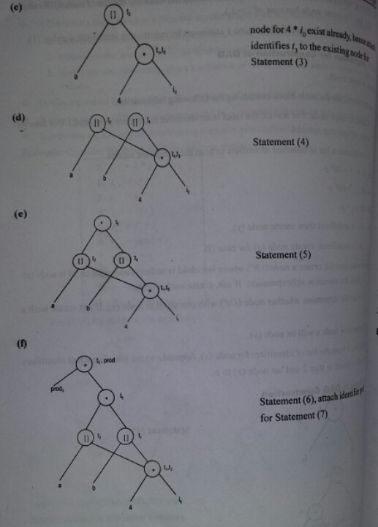
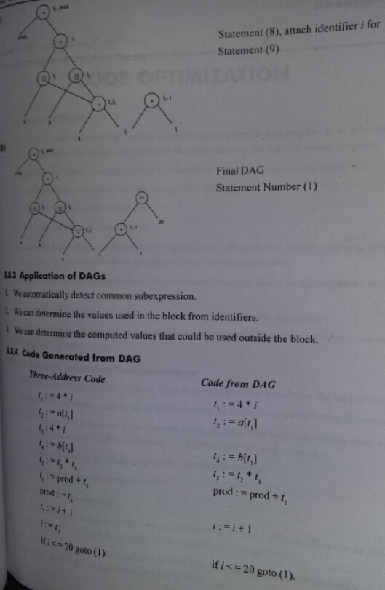

4.7 THE PRINCIPAL SOURCES OF OPTlMIZATION
- A transformation of a program is called local if it can be performed by looking only at the statements in a basic block; otherwise, it is called global.
- Many transformations can be performed at both the local and global level. Local transformations are usually performed first.

Function - preserving transformations
A Compiler can improve a program without changing the function it computes.
- Common sub expression elimination,
- Copy propagation
- Dead-code elimination
- Constant folding

Common Sub expressions
- An occurrence of an expression E is called a common sub expression if E was previously computed, and the values of variables in E have not changed since the previous computation, We can avoid re computing the expression if we can use the previously computed value.
- For Example, the assignments t₇ and t₁₀ have the common sub expressions 4* i and 4* j, respectively on the right side in Fig. 10.6(a). They have been eliminated in Fig. 10.6(b), by using t₆ instead of t₇ and t₈ instead of t₁₀. This change is what would result if we
- Re constructed the intermediate code from the dag for the basic block.

Copy Propagation
- Copy-propagation means use of one variable instead of another.
- For example.
x=PI;
…
…
a=x*r*r;

- The optimization using copy propagation can be done as follows
a=PI * r * r
Here the variable x is eliminated.

Dead Code Elimination
- A variable is live at a pint in a program if its value can be used subsequently; otherwise, it is dead at that point. A related idea is dead or useless code, statements that compute values that never get used.
Example:
i:=0;
if (i==1)
{
a=b+5;
}
- Here if statement is a dead code because this condition will never get satisfied. Hence if statement can be eliminated.

Constant folding
The substitution of values for names whose values are constant
A=3.14157/2 can be replaced by
A=1.570 there by eliminate the division operation.

Loop optimization
The running time of a program may be improved if we decrease the number of instructions in an inner loop, even if we increase the amount of code outside that loop.
Three techniques for loop optimization are
- Code Motion
- induction-variable elimination
- reduction in strength

Code Motion
An important modification that decreases the amount of code in a loop is code motion. This transformation takes an expression that yields the same result independent of the number of times a loop is executed and places the expression before the loop.
For Example,
While(i<=n-2)
{
------
------
}
Evaluation of n-2 is a loop invariant computation in the above while statements. So this can be placed outside the loop.
Code motion will result in the equivalent of
t=n-2
While(i<=t)

Reduction in Strength
- Reduction in strength replaces expensive operations by equivalent cheaper ones on the
target machine. Certain machine instructions are considerably cheaper than others and
can often be used as special cases of more expensive operators.
- For example, x² is invariably cheaper to implement as x*x than as a call to an exponentiation routine. Fixed-point multiplication or division by a power of two is cheaper to implement as a shift. Floating-point division by a constant can be implemented as multiplication by a constant, which may be cheaper.

4.8 PEEPHOLE OPTIMIZATION
- A statement-by-statement code-generation strategy often produces target code that contains redundant instructions and sub optional constructs.
- The quality of such target code can be improved by applying "optimizing" transformations to the target program.
- A simple but effective technique for locally improving the target code is peephole optimization. a method for trying to improve the performance of the target program by examining a short sequence of target instructions (called the peephole) and replacing these instructions by a shorter or faster sequences, whenever possible.
Characteristic of peephole optimizations
- redundant-instruction elimination
- flow-of-control optimizations
- algebraic simplifications
- use of machine idioms

Redundant-instruction elimination
( 1 ) MOV R0, a
(2) MOV a, R0
we can delete instruction (2) because whenever (2) is executed, ( 1) will ensure that the value of a is already in register RO.

Unreachable code
Another opportunity for peephole optimization is the removal of unreachable instructions.

#define debug 0
. . .
if (debug) {
print debugging information
}

Flow of control Optimizations
- The intermediate code generation algorithms frequently produce jumps to jumps, jumps to conditional jumps, or conditional jumps to jumps.
- These unnecessary jumps can be eliminated in either the intermediate code or the target code by the following types of peephole optimizations. We can replace the jump sequence.
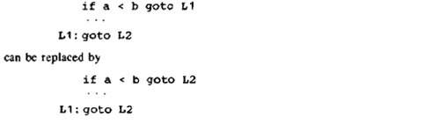
Algebraic Simplification
- There is no end to the amount of algebraic simplification that can be attempted through peephole optimization. However, only a few algebraic identities occur frequently enough that it is worth considering implementing them.
- For example, statements such as
are often produced by straightforward intermediate code-generation algorithms, and they can be eliminated easily through peephole optimization.

Reduction in Strength
- Reduction in strength replaces expensive operations by equivalent cheaper ones on the target machine.
- For example, x² is invariably cheaper to implement as x*x than as a call to an exponentiation routine.

Use of machine idioms
- The target machine may have hardware instructions to implement certain specific operations efficiently, Detecting situations that permit the use of these instructions can reduce execution time significantly.
- For example, some machines have auto-increment and auto-decrement addressing modes, These add or subtract one from an operand before or after using its value. The use of these modes greatly improves the quality of code when pushing or popping a stack, as in parameter passing. These modes can also be used in code for statements like i : =i+ 1.

